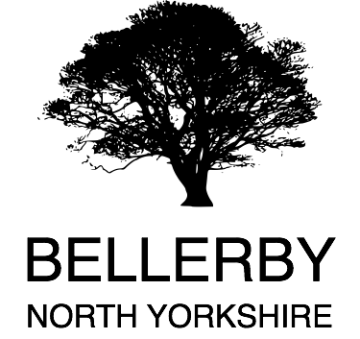
BELLERBY PARISH COUNCIL
21st August 2017
Dear
Partnering Project
As a Parish Council we’re finding it increasingly difficult to procure trades to complete relatively low value pieces of work, while complying with financial regulations for 3 tenders. Quite simply it’s costly for a small firm to visit site, and submit estimates and tenders for relatively small pieces of work. We have also been told that a further 2 charitable trusts in our village are experiencing the same problem.
We have had a suggestion that we could band together to procure these services and tender a minimum fixed amount of value of work per year (or a potentially longer period). This could have an additional benefit of supporting a local small business with a guaranteed minimum income per year, or help a start-up business in the local area.
In short, the question is would your Parish Council be interested?
If so, I’m prepared to take this forward as a project to develop further, ideally with the support of Richmondshire District Council, and apply for a small amount of funding to get the project off the ground.
If you would be so kind as to raise this at your next Parish Council or Parish Meeting, and respond accordingly, we can develop the principle further and take it to the Area Partnership Forum for further discussion.
Kind Regards

John Hutchinson
(Chair – Bellerby Parish Council)
Carperby cum Thoresby | Mrs Gillian Harrison  Clerk to Carperby cum Thoresby Parish Council  The Old Calf House  Manor Farm  Thornton Rust  Leyburn, North Yorkshire  DL8 3AN  Tel: (01969) 663 847  Email: gillian.harris@btconnect.com
Constable Burton & Finghall  (including the Parishes of Akebar, Barden, Constable Burton, Finghall, Garriston, East and West Hauxwell, Hutton Hang) | Mrs Joan Hainsworth  Clerk to Constable Burton & Finghall Parish Council  Hargill House  Finghall  Leyburn, North Yorkshire  DL8 5ND  Tel: (01677) 450 245  Email: hargillhouse@btinternet.com
Harmby | Mr Charles Payne  Clerk to Harmby Parish Council  Manor Barn  Harmby  Leyburn, North Yorkshire  DL8 5PD  Tel: (01969) 623 393  Email: swiftsden@hotmail.co.uk
Middleham Town | David Keep  Clerk to Middleham Town Council  Town Clerk’s Office  Middleham Key Centre  Park Lane  Middleham  Leyburn, North Yorkshire  DL8 4RA  Tel: (01969) 625 225  Email: middleham-council@btconnect.com
Preston under Scar | Lynn Watkinson  Clerk to Preston under Scar Parish Council  5 Belle Vue Terrrace  Bellerby  Leyburn, North Yorkshire  DL8 5QL  Tel: (01969) 623 116  Email: prestonunderscarpc@gmail.com  Website: http://www.prestonunderscarpc.co.uk
Redmire | Jackie Ayre  Clerk to Redmire Parish Council  4 Downholme Village  Richmond, North Yorkshire  DL11 6AE  Tel: (01748) 519 508  Email: redmirePCclerk@outlook.com
West Witton | Mrs Tracy Harker  Clerk to West Witton Parish Council  3 Old School Close  West Witton  Leyburn, North Yorkshire  DL8 4NF  Tel: (01969) 624 279  Email: westwittonparishclerk@yahoo.co.uk
Castle Bolton with East & West Bolton | Mrs Gillian Harrison  Clerk to Castle Bolton with East and West Bolton Parish Meeting  The Old Calf House  Manor Farm  Thornton Rust  Leyburn  North Yorkshire  DL8 3AN  Tel: (01969) 663 847  Email: gillian.harris@btconnect.com
Spennithorne | Mrs Norma Croft  Clerk to Spennithorne Parish Meeting  Mill Lodge  Spennithorne  Leyburn  North Yorkshire  DL8 5PR  Tel: (01969) 624 077  Email: norma@milllodge1234@plus.net
Wensley | Diane Arnold  Clerk to Wensley Parish Meeting  Low Yard Barn  Low Lane  Wensley  Leyburn  North Yorkshire  DL8 4HS  Tel: (01969) 326148  Email: dianearnold@live.co.uk

